Learning from strategy design pattern

**Brief explanation:**

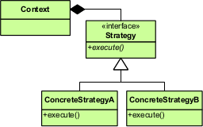

(Ref: <http://upload.wikimedia.org/wikipedia/commons/3/39/Strategy_Pattern_in_UML.png>)

* Strategy design pattern is typically used in places where you want to change behavior of algorithm at run-time.
* For example—
  + Suppose you have various compression algorithm such as Huffman, LZW etc. and you would like to use these algorithms based on some situations, choosing STRATEGY will be a good choice
  + In resource-allocation system, various strategies such as minimizing fragmentation, disk-access etc. are required based on what user want to optimize.
  + In web-services, you may ask data in json/xml/text format. Typically the back-end will have ‘**serialize ()’** method and based on format asked, it will convert to required format using strategy pattern.
  + Suppose you have many authentication schemes such as RSA-encryption (Custom), Facebook authentication or Google authentication etc. you may choose any of the mentioned strategies in your application using strategy design pattern. Passport.js uses strategy pattern to encapsulate various kind of authentication providers.